**Experiment-4**

**Design a smartphone controlled device.**

**Circuit diagram:**

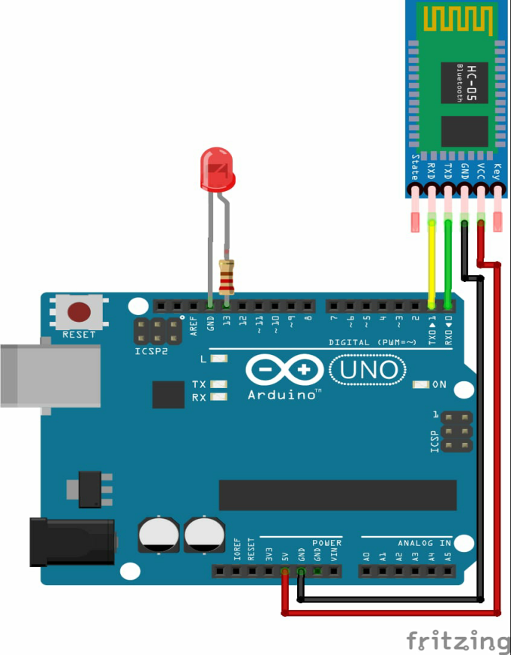

**Theory:**

# CONCEPT USED:

* By using kirchoff’s voltage law
* By using kirchoff’s current law
* Wireless technology
* Radiation & wave frequency

# LEARNING AND OBSERVATIONS:

* Connections in Breadboard and wiring.
* How to control arduino and its coding.
* Use of multimeter for continuity.
* Proper use of bluetooth

**OBSERVATION:**

* Controlling of devices through a remote
* Relation between software and hardware.
* Varation of frequency

# PROBLEMS & TROUBLESHOOTING:

* To select the right port and type of arduino
* To check the loose connections
* To check the connections according to the codes
* To check the continuity of the circuit
* To check the flow of current in the circuit
* Errors in code

# **PRECAUTIONS:**

* Handle tools carefully
* Wear gloves
* Do not connect arduino till the circuit is complete
* Do not connect leds without a variable resistor
* Proper Bluetooth module

# OUTCOMES:

* Making of wireless controlled devices
* By bluetooth module
* Proper use of Arduino and breadboard